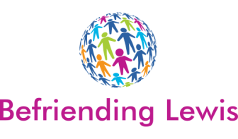

BEFRIENDER ROLE OUTLINE

Role title:
Befriender
Based at:
We are looking for volunteers throughout Lewis who can spend time with individuals who may be socially isolated for a variety of reasons. This can take place in the client’s home or elsewhere, for example a café. We also offer a telephone Befriending Service.
Purpose of the role:
To help reduce feelings of loneliness and promote social activities and contact with individuals who are socially isolated.
Type of work you will be carrying out:
Spending a couple of hours a week with someone either in their home or outside. You could take part in a range of social activities, such as going for a coffee, going to the cinema, or going for a walk. A telephone Befriending match would involve spending an hour a week on the phone chatting with the Befriendee.
Experience, attributes and/or qualifications required:
We require someone:
- Aged 18 or over
- Interested in working with the people of all ages, or those with mental health problems or additional needs
- Prepared to commit some of their time (usually around 2 hours per week)
- Prepared to have fun and participate in outings and activities.
- Attend 2 X 2.5 hour Training Sessions prior to commencing Befriending.
- Attend Quarterly Meetings & Ongoing Training
Times/days when we would like you to be available:
We would like you to commit to spending a minimum of 2 hours a week with the client. This would have to be a time that is suitable for you both. You can, of course, commit more time if that is agreeable to both of you.
Benefits to volunteering and possible training opportunities:
- Improved social networks
- An opportunity to meet new people
- Increased confidence
- Learn new skills
Expenses paid:
Travel expenses will be covered

References/PVG checks required:
2 references and an enhanced disclosure are required, due to the volunteer working in close proximity with vulnerable adults.
If you are interested in this volunteering opportunity please contact:

Befriending Lewis
Third Sector Hebrides
30 Francis Street
Stornoway
Isle of Lewis
Tel: 01851 702632

Email: befriending@tshebrides.org.uk

